Moel Y Penmaen OS 72414 30146
The hillside to the east of the A470 between Traswfynydd and Dolgellau has this amll but excellent collection of rock faces . Pass through the holiday village in Bronaber , then take the right fork , and on reaching a small chapel on the roadside pass though the gate opposite and drive up to the hillside
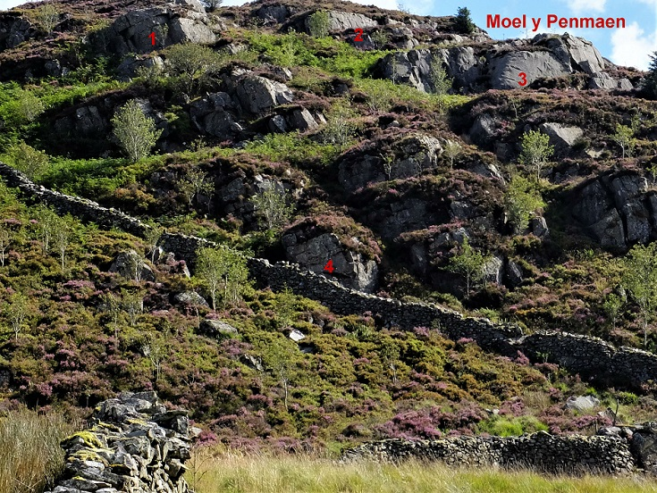

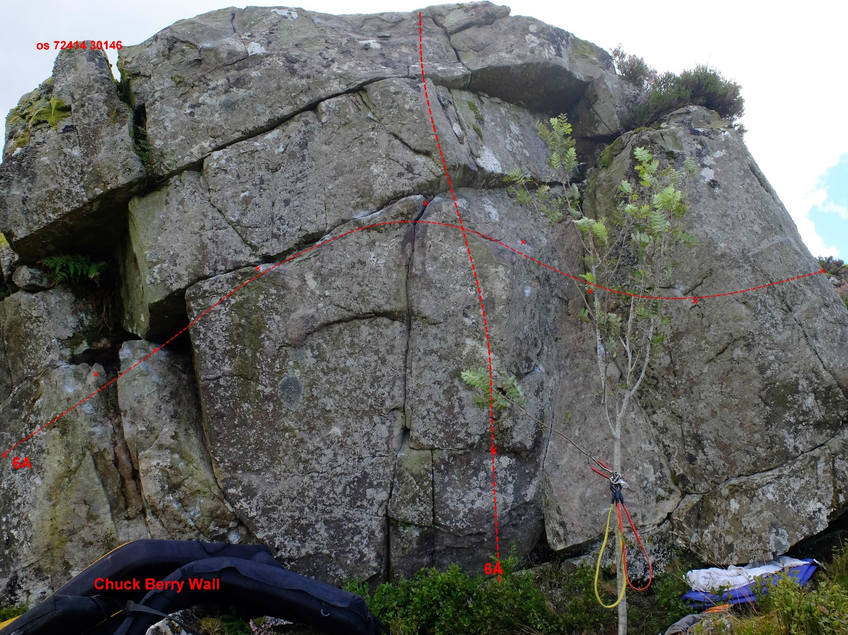
Section1 : Chuck Berry L - R sds 6A, direct with sds is also 6A
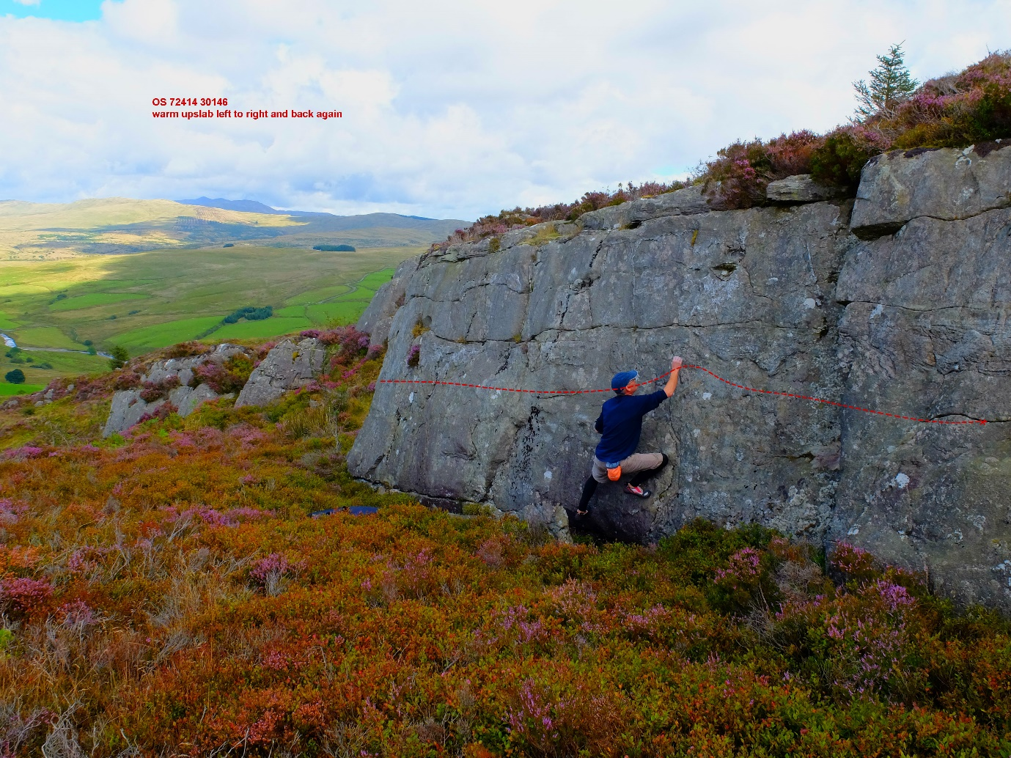
A nice easy warmup L-R and back agin below the horizontal reak

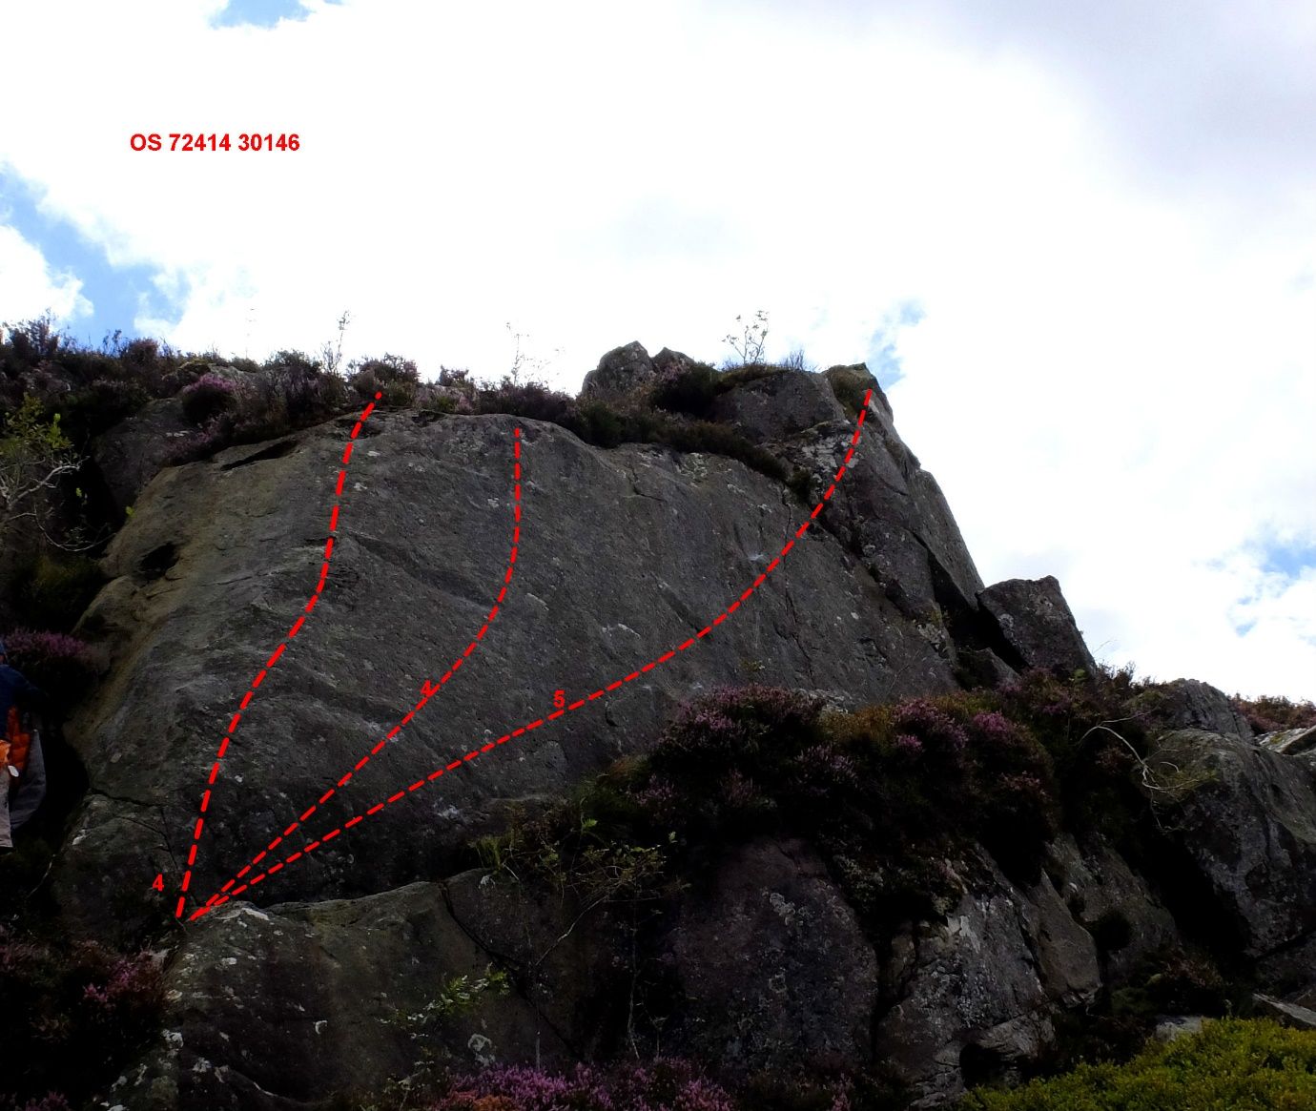
Section 3: wonderful slab with 3 problems , 4, 4 and 4+

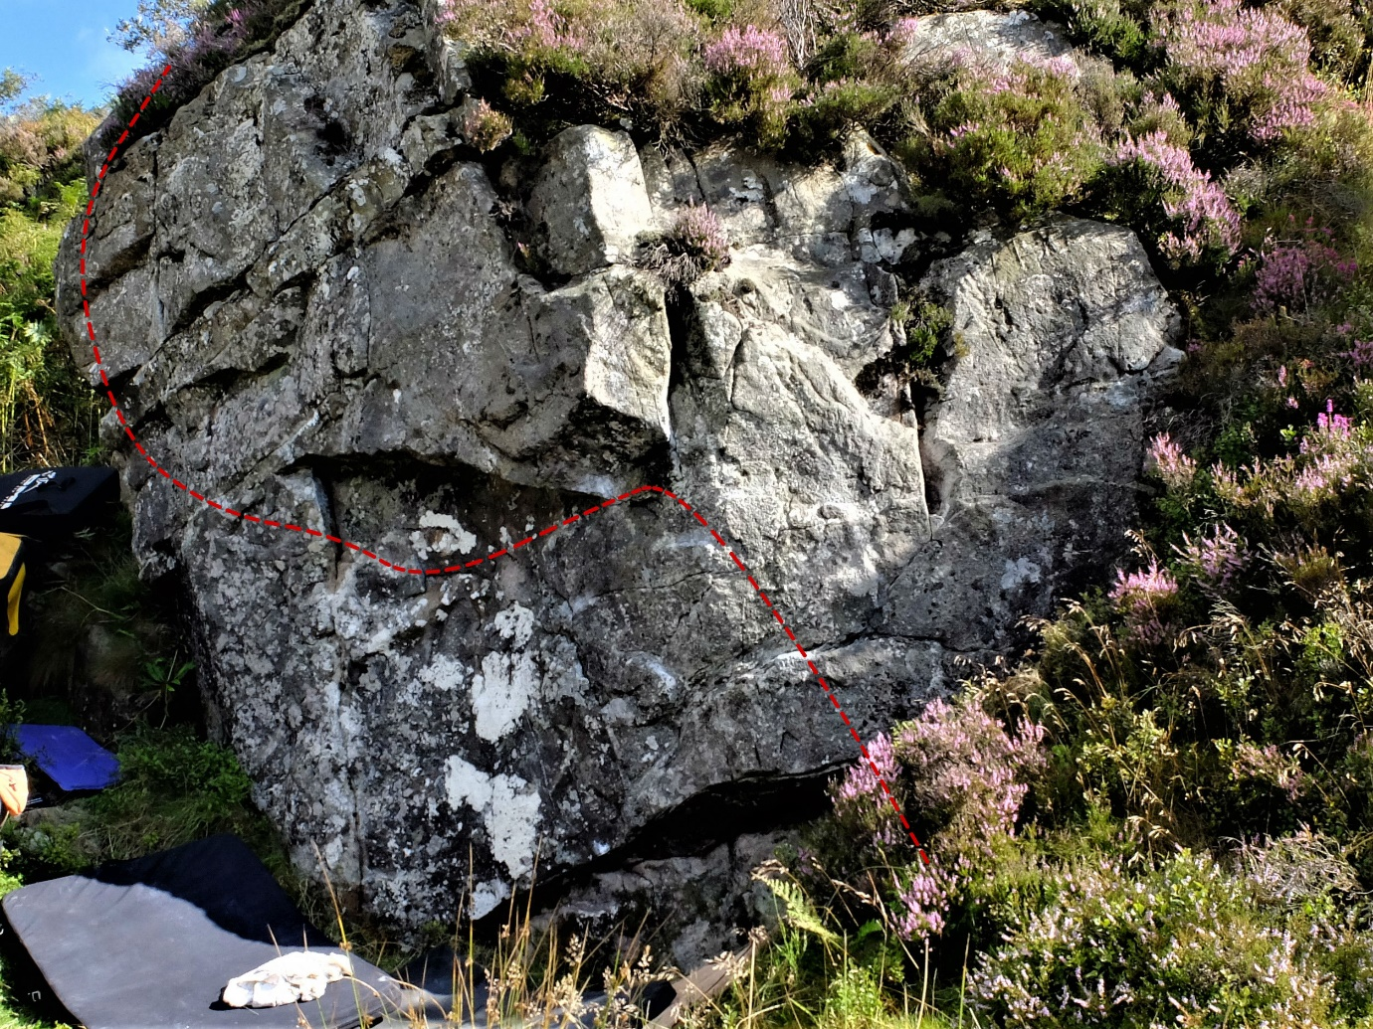
Section 4 : the promised land right to upper left sds 6B

